12 Creating a Project Page Overlay

<https://www.youtube.com/watch?v=_a5j7KoflTs>

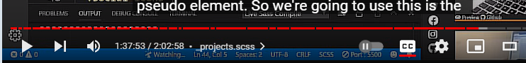

# Turn on Sass

In Visual Studio

Remember to turn on your Watch Sass

